2014 – 2015
NCSILC Board Member Locations
4
3
2
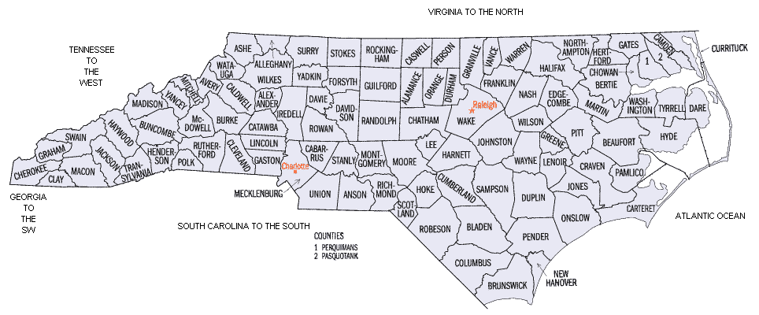
1
= Board Member
= Ex-Officio Member

