**STATEWIDE INDEPENDENT LIVING COUNCIL**

**QUARTERLY REPORT**

**DIVISION OF VOCATIONAL REHABILITATION**

**May 5, 2017**

Concerns:

**Lack of transparency and collaboration:**

* The Legislative request to take money from the DVR IL program and disperse to the CILs without any dialogue with DVR and without a vote from SILC members does not exemplifying the spirit of transparency to its members and collaboration with DVR.
* The new ruling to allow only 3 minutes of ex-officio reporting in a stifling format does not support the spirit of collaboration.

**GOAL 6 Update**

|  |  |  |
| --- | --- | --- |
| NCVRIL and DSB provide quality services as needed by people with disabilities | Objective 6.1 DSB and DVRS provide services and supports to enhance the quality of life for people with disabilities.  Activities:  * Annually, DVRS provides home modifications to a minimum of 500 consumers.  * Annually, DVRS provides personal assistance services to a minimum of 200 consumers  * Annually, DVRS provides physical restoration services to a minimum of 100 consumers.  * Annually, DVRS provides community-based transition supports to a minimum of 30 consumers. | Goal Met  Goal Met  Goal Met  In Progress |
| NCVRIL and DSB provide quality services as needed by people with disabilities | Objective 6.2 DSB and DVRS provide assistive technology supports to enable people with disabilities to increase independence at home and in the community.  Activities:  * Annually, DSB provides a minimum of 2 technology group trainings to consumers.  * Annually, DSB and DVRS provide assistive technology training to a minimum of 100 participants in the community. | Goal Met  Goal Met |
| NCVRIL and DSB provide quality services as needed by people with disabilities | Objective 6.3: DSB and DVRS enable Veterans with disabilities to receive seamless supports and services to live independently.  * Annually, DSB and DVRS participate in 5 events to increase communication and collaboration with the Veterans Administration and other programs serving Veterans. | In Progress  Goal Met |

**VR IL UPDATE**

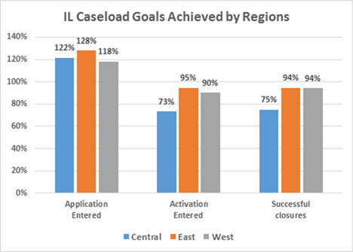

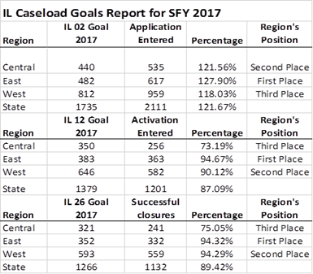

**VR ASSISTIVE TECHNOLOGY UPDATE**

Number of Consumers Served (demos, loans, info/assistance): 19,531

Number of People Attending Training/Awareness Events: 1,766

**VR EMPLOYMENT UPDATE**

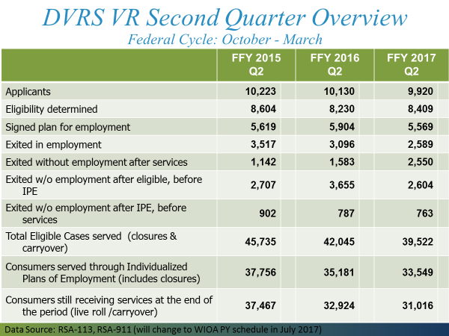

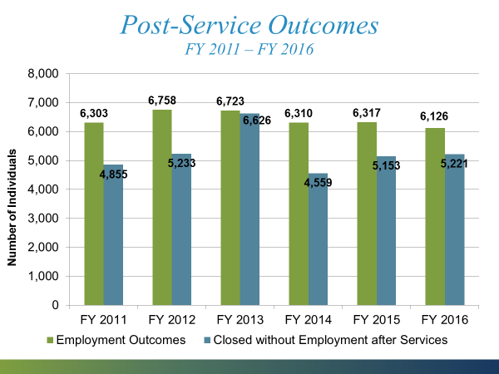

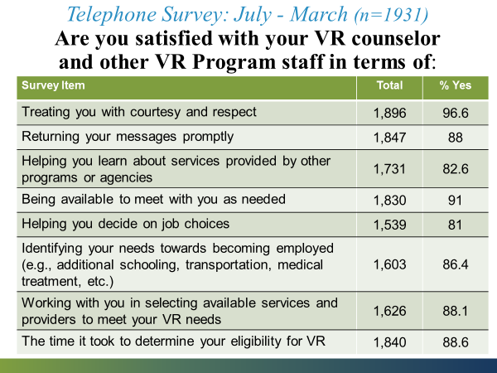

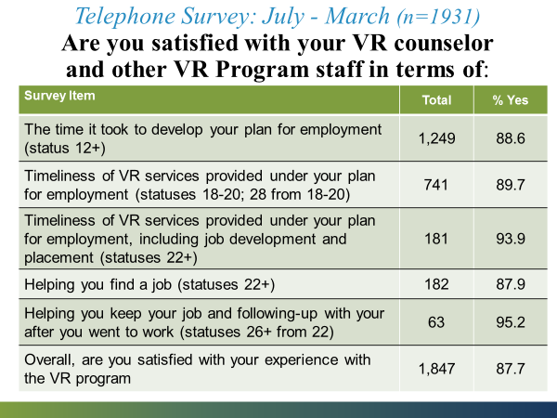

**PART B CONTRACT UPDATE**



Contract renewal SOW and budgets were due May 1, 2017. To date, we have received the following:

* + The Adaptables
  + Alliance for Disability Advocates
  + Disability Rights & Resources
  + Joy A. Shabazz Center