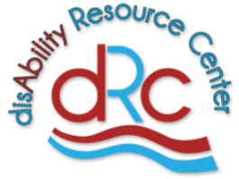
disAbility Resource Center Presents:
2020 Rural Event - “Unplugged”

Who: Youth with disabilities Ages 16-26 who reside in
Brunswick, Columbus, Onslow and Pender Counties

What: Social Media Safety

When: July 21, 2020 @ 10:00-11:00am

Where: via Zoom platform
MUST PRE-REGISTER FOR LOGIN INFORMATION
Accommodations available upon request.
If interested contact:
Stevie Toole, Youth Transition Coordinator
(910) 815-6618 or stevie.toole@drc-cil.org

